**Bug ID:** 1

**Bug Summary:** Calculator doesn't work properly, addition doesn’t work

**Environment/URL:** Calculator-app.exe

**Operation System:** Windows 64

**Version**: 1

**Browser:** Microsoft Edge

**Submit Date:** 28/03/2023

**Reporter:** Aghavni Harutyunyan

**Steps to Reproduce:**

1. Open calculator-app.exe

2. Addition doesn’t work

**Expected Result:** Adding the numbers should give me the correct answer

**Actual Result:** After writing the numbers, I press addition, it calculates incorrectly

**Screenshot/video:**

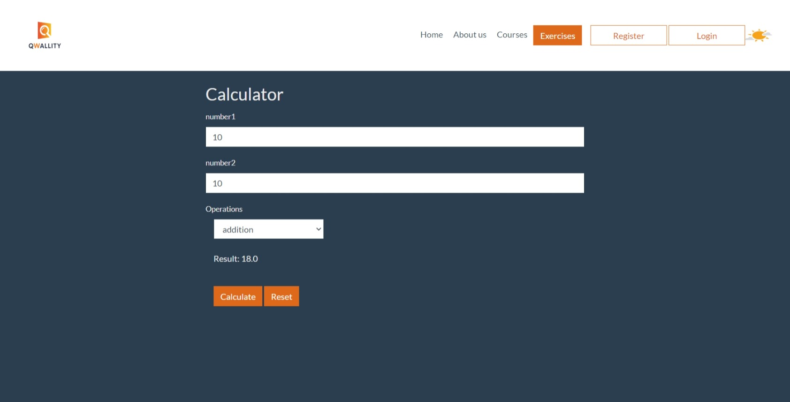

**Notes:** Other numbers working correctly, after pressing the display in window.

**References: -**

**Severity:** Critical

**Bug ID:** 2

**Bug Summary:** Calculator doesn't work properly, reset don’t clear numbers

**Environment/URL:** Calculator-app.exe

**Operation System:** Windows 64

**Version**: 1

**Browser:** Microsoft Edge

**Submit Date:** 28/03/2023

**Reporter:** Aghavni Harutyunyan

**Steps to Reproduce:**

1. Open calculator-app.exe

2. Reset don’t clear numbers

**Expected Result:** When I press the reset, numbers should be clean

**Actual Result:** After press the reset my numbers nothing change

**Screenshot/video:**

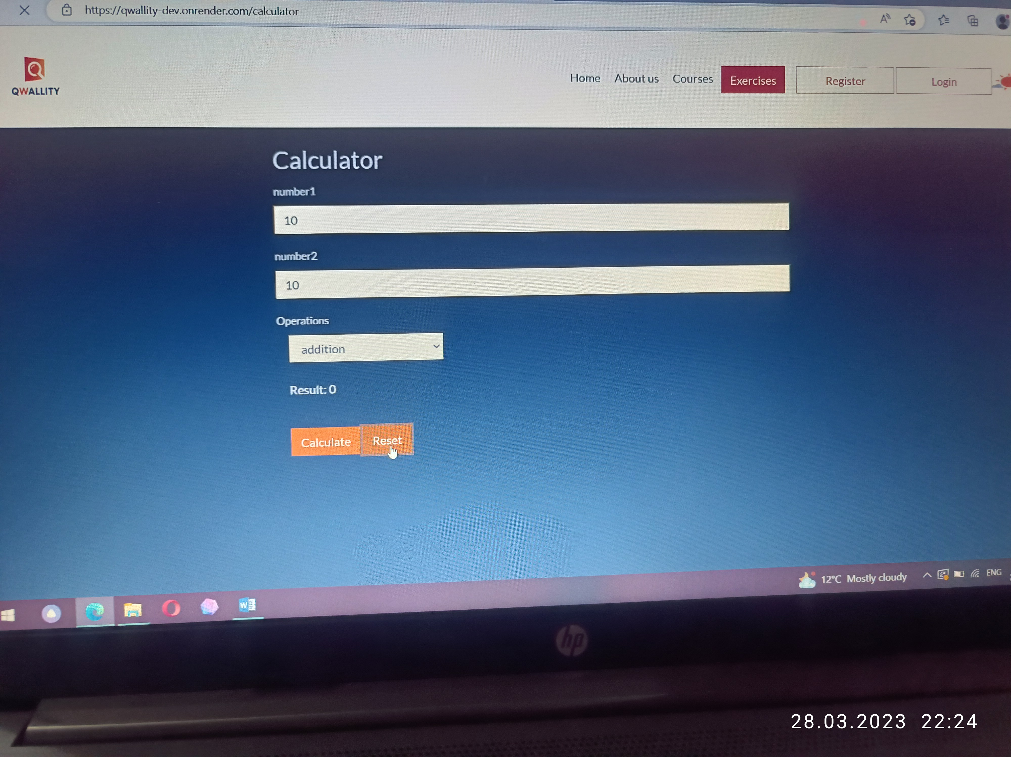

**Notes: References: -**

**Severity:** Major

**Bug ID: 3**

**Bug Summary:** Calculator doesn't work properly, divition by zero bring the message, where the word is spelled incorrectly

**Environment/URL:** Calculator-app.exe

**Operation System:** Windows 64

**Version**: 1

**Browser:** Microsoft Edge

**Submit Date:** 28/03/2023

**Reporter:** Aghavni Harutyunyan

**Steps to Reproduce:**

1. Open calculator-app.exe

2. Divition by zero bring the message, where the word is spelled incorrectly

**Expected Result:** Any number divided by zero would get zero

**Actual Result:** divition by zero bring me a message, where the word is spelled incorrectly

**Screenshot/video:** 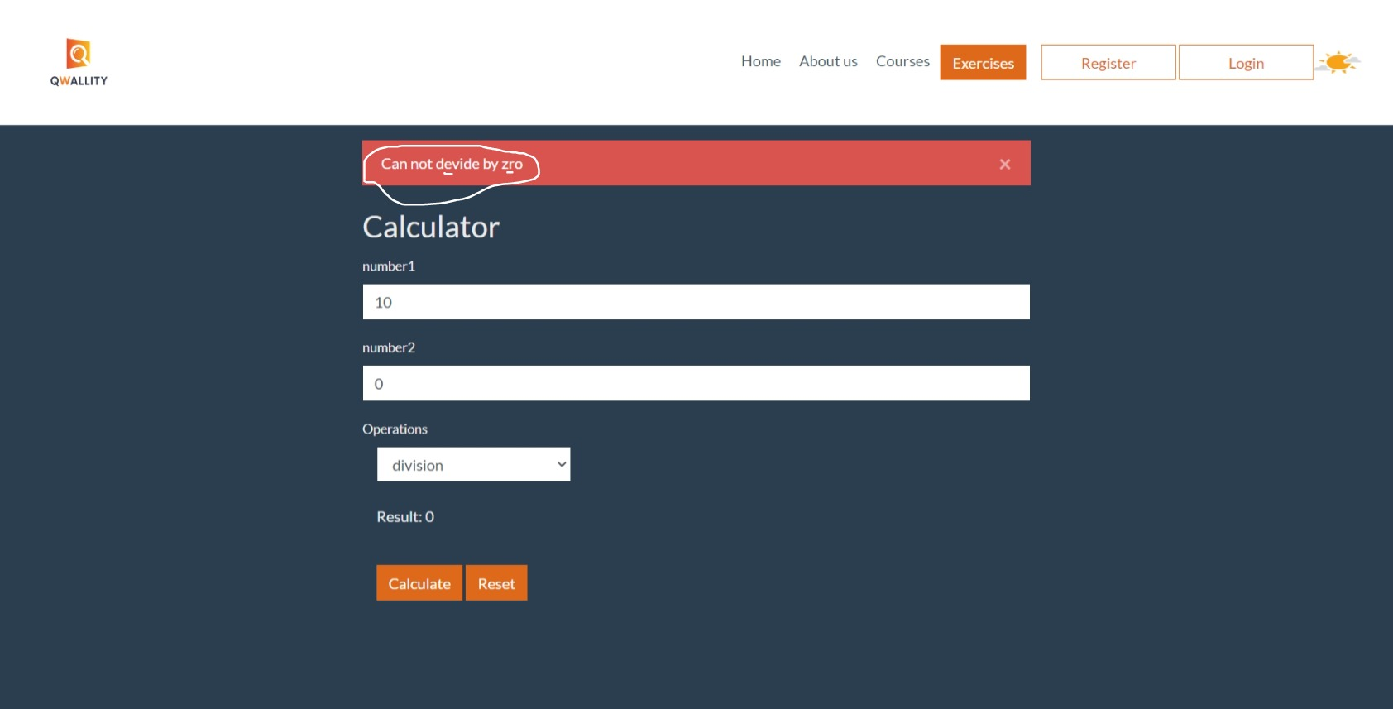

**Notes:**.

**References: -**

**Severity:** Critical